Q: one of the ways to solve a setup violation is applying a positive clock skew. Is this only a backend solution?
A: No, it can be done in frontend by inserting a buffer on the clock path at RTL, and then we apply set_dont_touch on that buffer so that synthesis and CTS do not remove or optimize it away.
Q: what’s the problem with the following circuit?
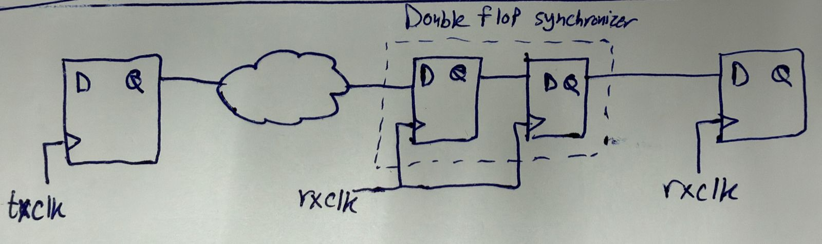
A: combo logic before double flop synchronizer. Correct circuit:
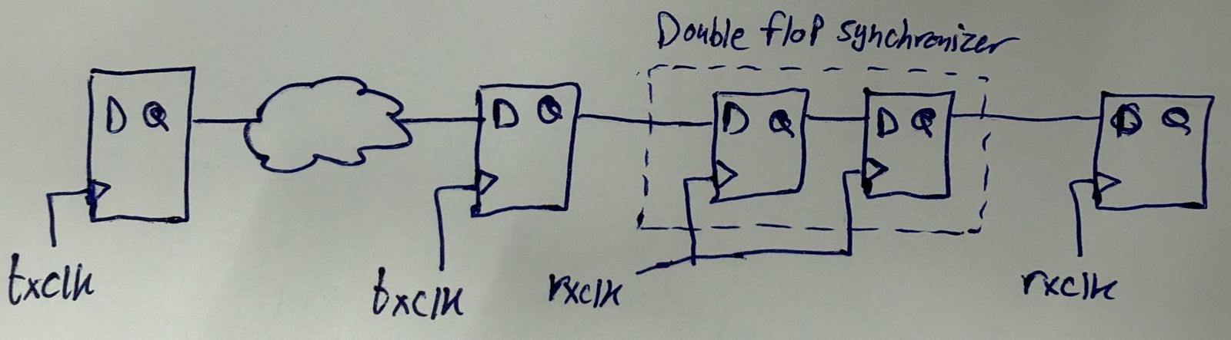
Q: as a designer, how can you prepare your RTL design for DFT insertion (which will be done by the backend engineer)?
A: you should mention the “RTL Preparation for DFT” steps in Temsah’s session.
Q: What is the worst thing that could happen from metastability?
A: very high short-circuit power which could burn the chip
Q: what is the minimum and maximum latency of a double-flop synchronizer?
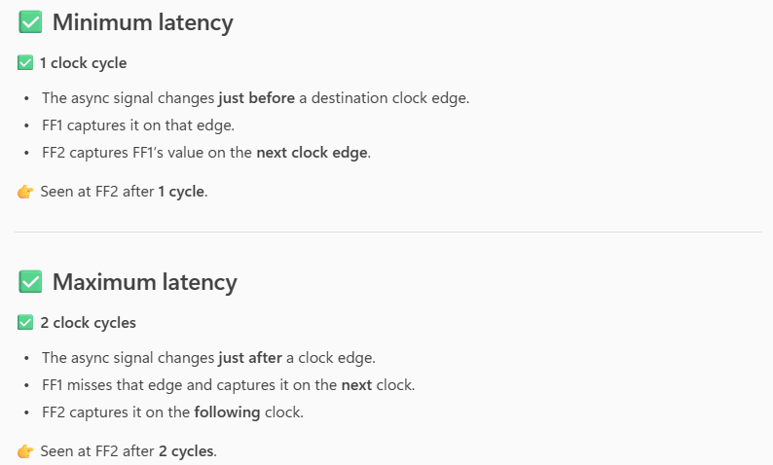
Q: how can we solve the setup violation in the following circuit?
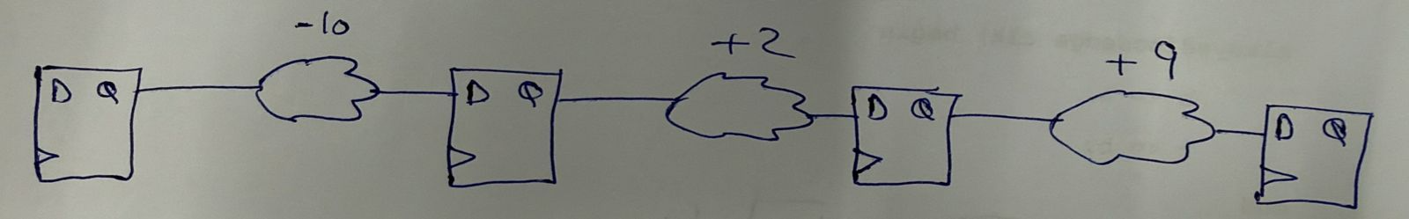
A: using retiming, where we shift some of the path with slack = -10 ps to the paths with +2 and +9 slacks.
Q: consider the case below. A 64-bit parallel bus is transferred from one block to another. It was noticed that, at every clock edge (i.e. when the 64 bits are captured by the destination block), a supply drop happens. How can we solve this?
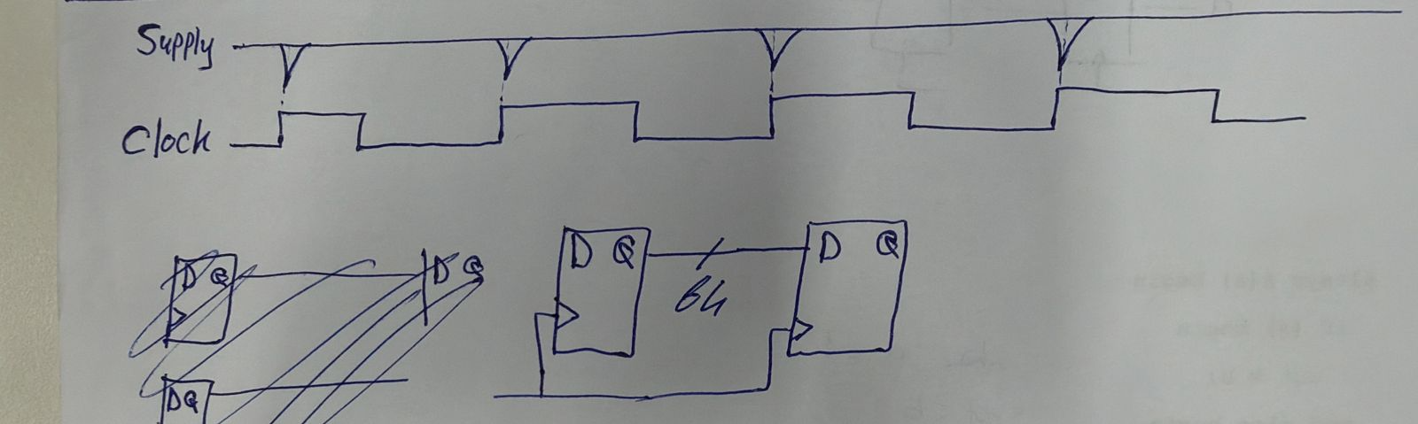
A: el awel nefham sabab el supply drop da eh. Delwa2ty lama el clock edge beyegy, el 64 bits kolohom beyed5olo 3la el destination flip flops ye3melo transition, y3ny by7sl maximally 64 switches 3al destination flip flop. This loads the supply a lot and accordingly causes a drop on it. Thus, lazem nemna3 en el 64 bits kolohom yetne2lo mara wa7da. Fa n3ml eh? Awel fekra heya enena nastafeed be negative edge, fa nen2el 32 bits 3al positive edge w 32 bits 3al negative edge. Keda e7na 2alelna el voltage drop el nos 3la tool. Tab w eh kaman? Notlob men btoo3 el analog yetala3olna phases mo5talefa men el clock, b7ees a5la2 positive w negative edges gededa 3and time instants gededa. Fa masalan lw galna clock gededa el positive edge bta3ha beyegy fi nos el positive level of the clock drawn above and the negative edge beyegy fi nos el negative level of the clock drawn above, keda e7na 2asamna el voltage drop 3la 4, and so on. Bs n5ly balna men 7aga, e7na lazem nedman en el data mesh hatetghayar abl el edges el ketera el 3amalen netkalem 3leeha de. Fa masalan fel case bta3t enena hanesta5dem only el clock el marsoma foo2 de w hanesta5dem el negative edge, fa lazem ne make sure en el data stable ableh. W de el case hena, howa kan 2ally fel interview en el clock period hena kebera w mafehash gheer el Tcq bs, fa m3ana bara7.
Q: How can we transfer a pulse from a fast clock domain to another slower asynchronous clock domain?
A: lazem neb3at-ha high men el domain el awalany, ne synchronize it lel domain el tany, then fel domain el tany neb2a ne generate el pulse (using the pulse generator method you already know 3ady).
Notes from the meeting:
- El RDC da denya, mesh mogarad eny a7ot reset synchronizer 3al asynchronous reset keda w 5alas, me7tag te2ra aktar 3an el mawdoo3 w probably tegarab 3la Spyglass.
- 7ases eny fahem DFT kwayes bs 7etet el “ATPG” wade7 eny lesa mesh fahemha kwayes. Be ma3na en howa bzbt ma3na el pattern el beyegy men el ATPG? Ba2ol keda la2en ana olt fel interview “Beyeb2a fih aktar men scan chain, w kol scan chain leha its own SE signal”, fa homa e3tarado 3ala el gomla de gedan w sa2alony tab leeh olt “3ashan ana ama ab2a 3ayez a test target node mo3ayana, fa hab2a 3ayez a drive it be value mo3ayana, el value de hawasalha lel target node 3an taree2 eny a3mel el 3 steps btoo3 el DFT el homa shift in, capture, shift out. Fa bema en target nodes in different scan chains momken yeb2o fi amaken mo5alefa, fa momken masalan node te7tag 7 cycles for shift in then a7tag a lower SE, w node tanya te7tag 12 cycles for shift in then a7tag a lower SE, fa kol chain lazem yeb2a leha its own SE”. Bs el mohem en homa 2aloly la2 da ghalat w fel a5er heya SE wa7da bs, w en da door el ATPG en heya betesta5dem mathematical methods enaha te3mel ma3rafsh eh keda ye5alena ne7tag SE wa7da, fa da3bes y3ny fel mawdoo3 da.
- Search for “how to solve setup and hold violations on the same path”.

